DHARSHINI.S 241901026
EX NO:2 Date:30/7/26
LIVE FORENSIC INVESTIGATION USING AUTOPSY
Aim
To perform a basic forensic investigation of a Windows system using Autopsy and identify files, user activity, browser history, deleted files and other digital evidence.
Software Required
- Windows 10/11
- Autopsy
- One authorized laboratory/test computer
- USB drive, if required
Procedure
Step 1 – Open Autopsy
- Start Autopsy.
- Select Create New Case.
- Enter:
  - Case Name: Live_Forensics
  - Case Number: LF001
  - Examiner Name: Your Name
- Click Finish.
Step 2 – Add Evidence
- Click Add Data Source.
- Select Local Disk.
- Select the authorized test computer's C: drive.
- Click Next.
Important: Perform this only on the laboratory/test computer authorized by your instructor.
Step 3 – Select Ingest Modules
Select the following if available:
- Recent Activity
- File Type Identification
- Keyword Search
- Hash Lookup
Click Next / Finish.
Wait for the ingest process to complete.
Step 4 – Examine User Files
From the left panel, navigate to
Data Sources → C: → Users
Open the test user's folders:
- Desktop
- Documents
- Downloads
- Pictures
Identify any interesting files.
Record:
File Name | Location | File Type
Step 5 – Examine Browser Activity
Go to
Results → Recent Activity
Look for
- Web history
- URLs
- Downloads
- Browser information
Record any two relevant entries.
Date/Time | Website / URL | Browser
Step 6 – Search for a Keyword
Use Keyword Search.
Search for a simple laboratory keyword such as:
ProjectX
or
Evidence
Record the result.
Keyword | File / Location | Finding
Step 7 – Examine Deleted Files
Look under the available Deleted Files results.
Find one deleted file, if available.
Record:
- File name
- File type
- Location
- Size
- Deleted status
File Name | Type | Size | Status
Step 8 – Examine File Details
Select one important file.
Check the Content Viewer / File Details.
Record:
- File name
- Path
- Size
- Created time
- Modified time
- Accessed time
Step 9 – Tag Important Evidence
Right-click the important file.
Select:
Tag → Interesting Item / Notable Item
Add a short comment such as:
"File identified as relevant evidence during the investigation."
Step 10 – Generate Report
Go to
Tools → Generate Report
Select:
HTML Report
Generate the report.
Open the generated report and verify the evidence.

Observation
S.No. | Evidence Examined | Finding
1 | User files | Identified user documents, images, and other files available in the examined data source.
2 | Browser history | Examined available browsing history, including visited URLs and associated timestamps
3 | Downloaded files | Identified available downloaded files and their recorded file details
4 | Keyword search | Searched for specified keywords and identified matching files or text where available.
5 | Deleted files | Searched for specified keywords and identified matching files or text where available.
6 | File timestamps | Examined available file creation, modification, and access timestamps.
7 | Tagged evidence | Tagged relevant files and artifacts for further examination and reporting

Output
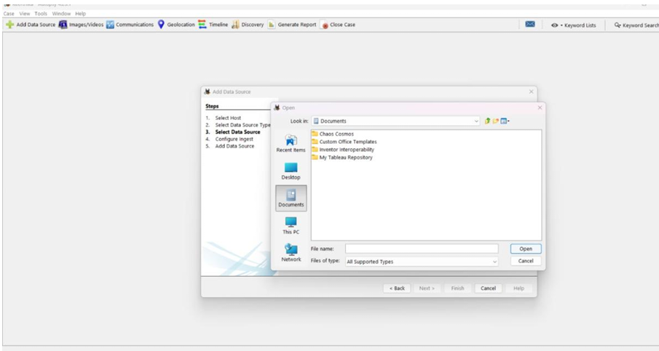

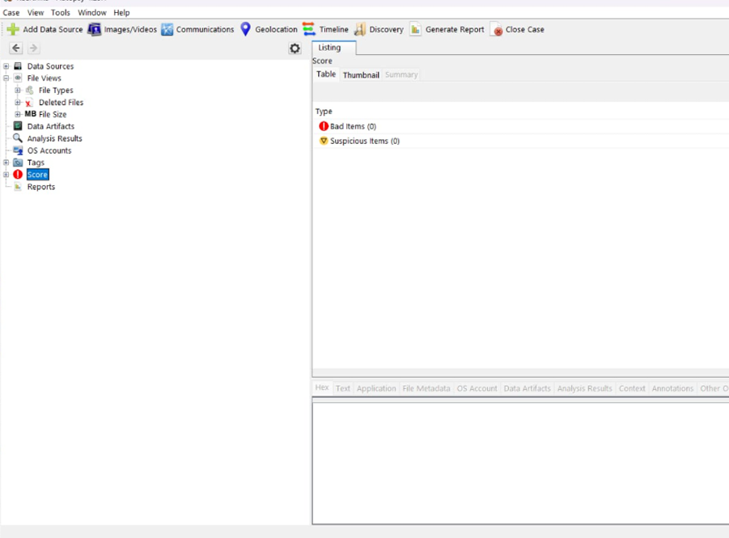
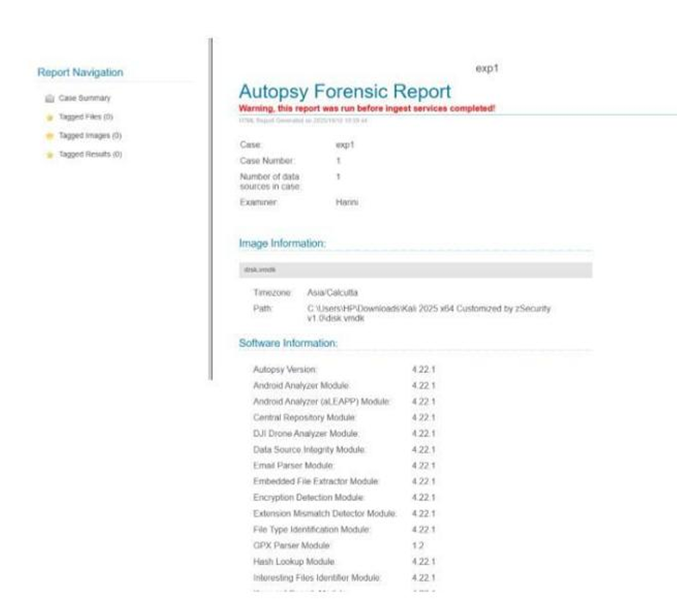

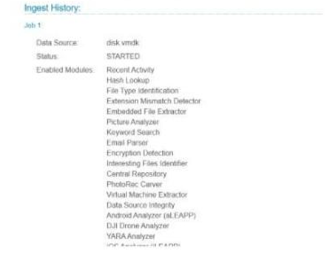


Result
The Windows test system was successfully investigated using Autopsy. Relevant digital evidence including user files, browser activity, deleted files and file metadata was identified, examined and documented. A forensic HTML report was successfully generated.

